**LAPORAN PRAKTIKUM**

**ALGORITMA DAN STRUKTUR DATA**

**MODUL 3. COLLECTIONS, ARRAYS, AND LINKED STRUCTURES**

3.1 Pengertian Collections

3.2 Array dan Array Dua Dimensi

Latihan 3.1

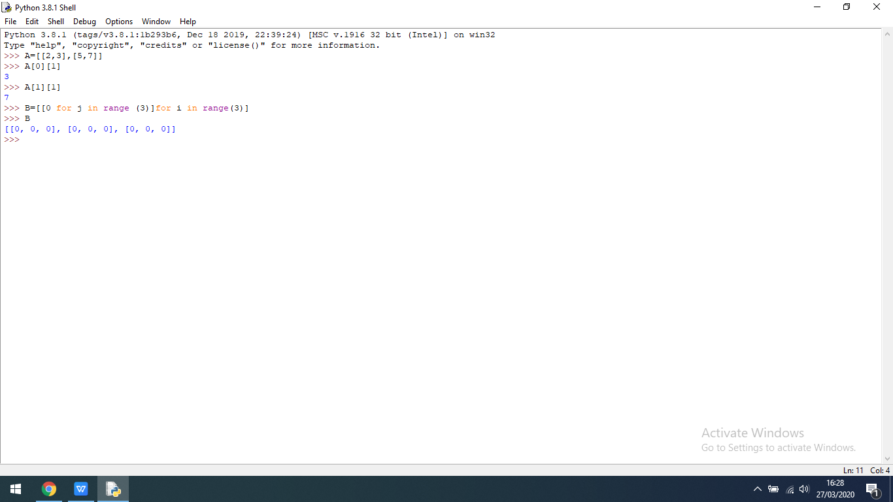

Latihan 3.2



3.3 Linked Structures

Linked List

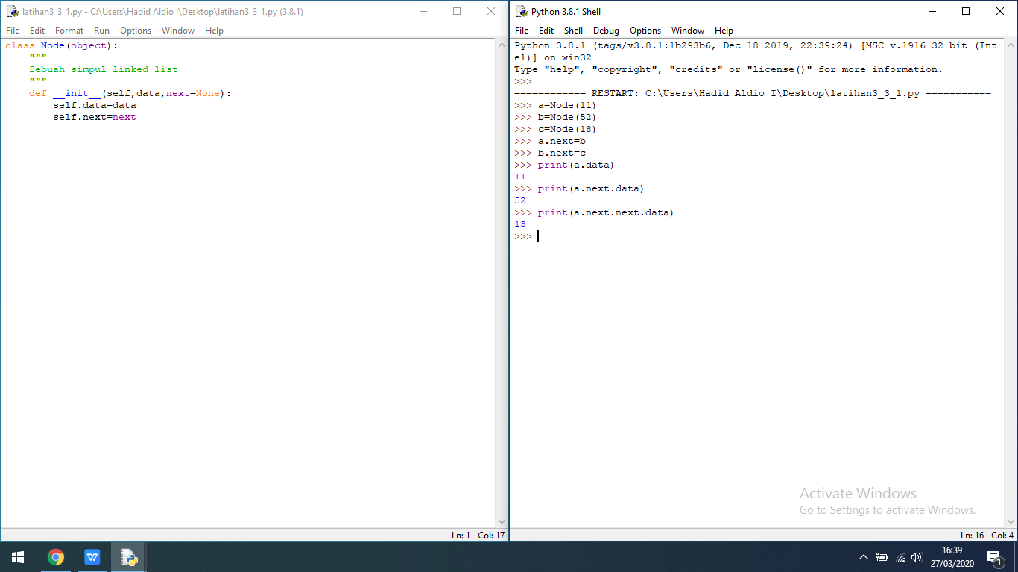

Advanced Linked List

